**3D Clipping**

In **2D Clipping** a **window is considered** as a clipping boundary **but** in **3D**  a **view volume is considered**, which is a box between the two planes, the front and the back plane

The part of the object which **lies inside the view volume will be displayed** and the part that **lies outside will be clipped**

For a parallel projection a box or a region is a rectangular area and in case of perspective projection it is a truncated pyramidal volume called a frustum of vision

The view volume has **6 sides**: Left, Right , Bottom, Top, Near and Far

Cohen Sutherland ‘s region code approach **can be extended** for 3D clipping as well

In 2D, a point is checked if it is inside the visible window/region or not but in 3D clipping a point is compared against a plane

**View Volume** in case of

i. Parallel Projection

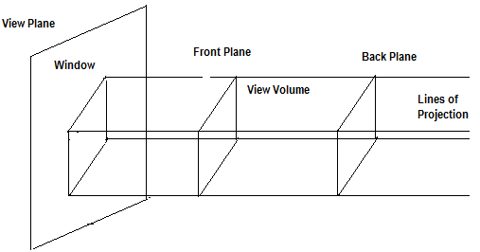

ii. Perspective Projection

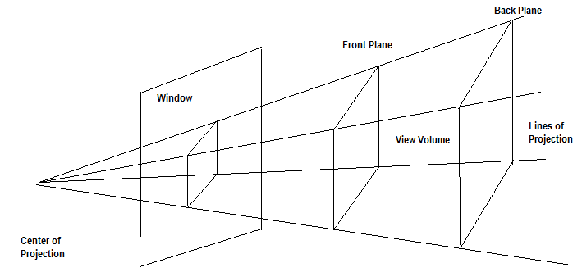

The front and back planes are positioned relative to the view reference point in the direction of the view plane normal

Here six bits are used to denote the region code

The bits are set to 1 as per the following rule:

Bit 1 is set to 1 if x < xvmin Bit 2 is set to 1 if x > xvmax

Bit 3 is set to 1 if y < yvmin Bit 4 is set to 1 if y > yvmax

Bit 5 is set to 1 if z < zvmin Bit 6 is set to 1 if z > zvmax

If both the end points have region codes 000000 then the line is **completely visible**

If the logical AND of the two end points region codes are not 000000 i.e. the same bit position of both the end points have the value 1, then the line is **completely rejected or invisible** else it is the case of **partial visibility** so the intersections with the planes must be computed

For a line with end points P1 (x1,y1,z1) and P2 (x2,y2,z2), the parametric equation can be expressed as:

x= x1 + (x2 – x1) u y= y1 + (y2 – y1) u z= z1 + (z2 – z1) u

If we are testing a line against the front plane of the viewport then z = zvmin and

u = (zvmin –z1)/(z2 –z1)

therefore xi= x1 + (x2 – x1) {(zvmin –z1)/(z2 –z1)}

yi= y1 + (y2 – y1) {(zvmin –z1)/(z2 –z1)}

where xi and yi are the intersection points with the plane